Instructions
- Log into OneUSG Connect.
- Click on Employee Self Service, then click Manager Self Service.
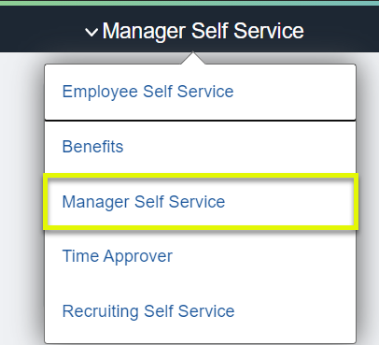
- From Manager Self Service, click the My Team tile.
Navigation:
Employee Self Service > Manager Self Service > My Team
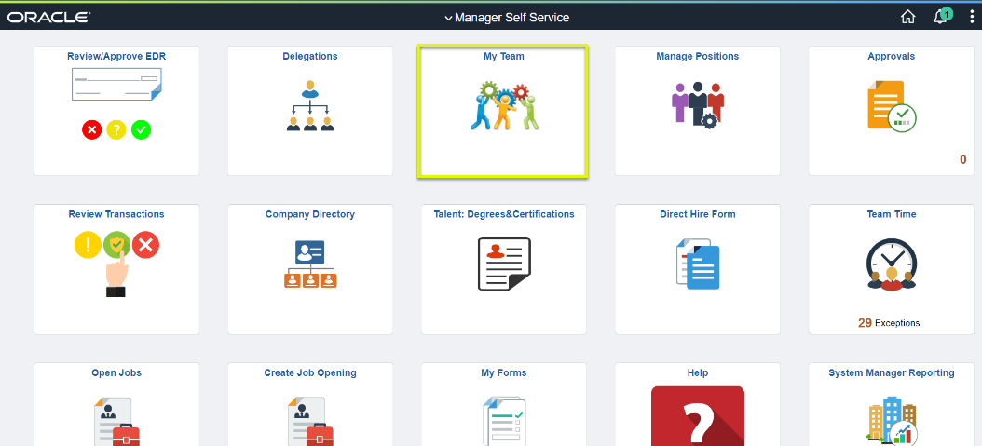
- Locate the employee you wish to request termination for and click the green action button (located next to their name).
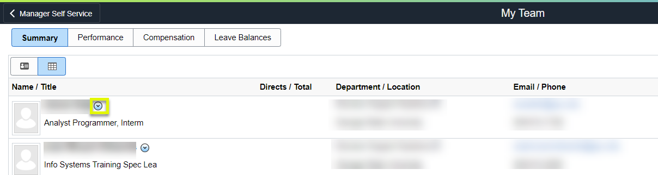
- Click Job and Personal Information.
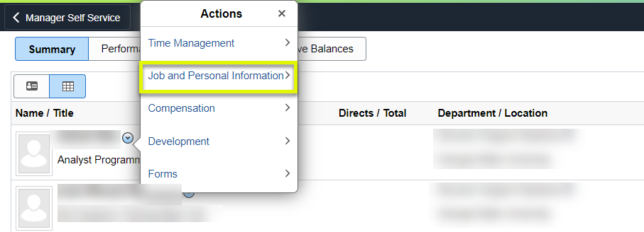
- Click Terminate Employee.
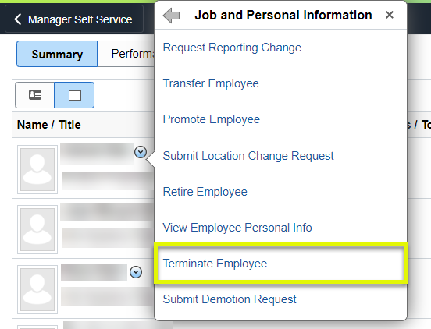
- On the Submit Termination Request page, verify the employee you wish to request termination for is listed.
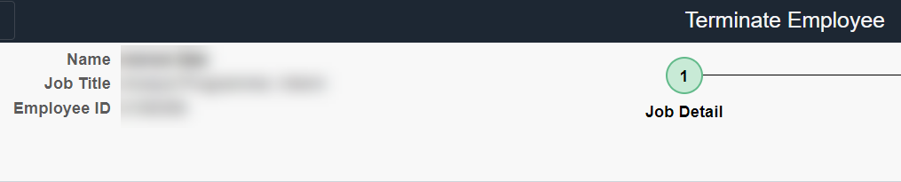
- Select or enter the requested Termination Date. The Termination Date is the first day the employee is no longer employed at the institution.
Note: The termination Effective Date is the first day that the employee is no longer employed at the institution.
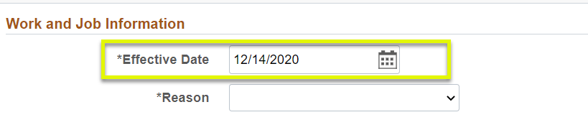
- Use the Reason dropdown to indicate the type of termination this is for the employee.
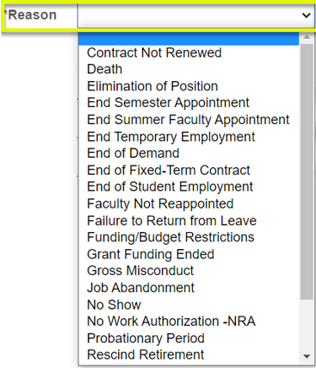
- Click Next in the upper right corner.
- Enter Comments and Attachments supporting your termination request, if necessary.
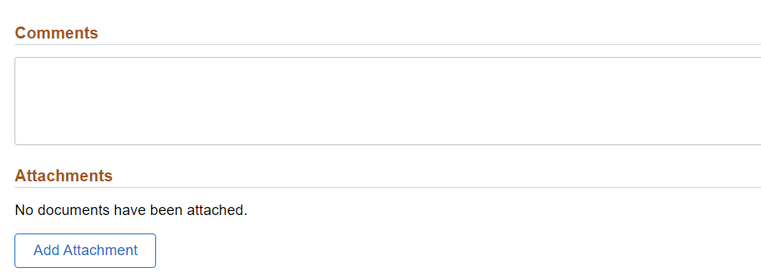
- Click Submit.

